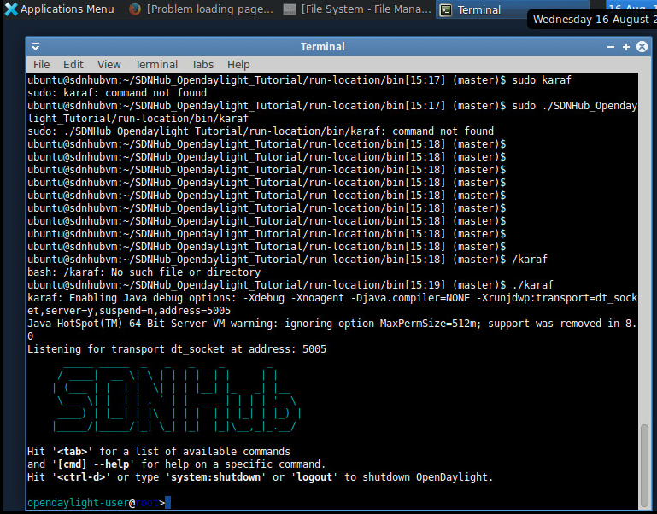

Username password ubuntu

Cd SDNHub_Opendaylight_Tutorial/run-local/bin

./karaf

ctrl+z